**COMPUTER**

**ORGANISATION AND ARCHITECTURE**

GROUP NINE

***Members***

1. **Manasseh Kipruto-** *SCCJ/01105/2018*
2. **Nicholas Muchiri-** *SCCJ/01100/2018*
3. **Brendah Gilisho-** *SCCJ/01098/2018*
4. **Dominic Kiptanui-** *SCCJ/01104/2018*
5. **Shadrack Pkiach-** SCCI/01161/2018

**QUESTION 9**

**(a)With the aid of a diagram, describe the functions and architecture of an I/O module.**

Functions

**i) Processor Communication**:

The processor communication involves the following tasks:

1. ***Exchange of Data*** :

Data are exchanged between the processor and the I/O module over the data bus.

1. ***Command Decoding*** :

The I/O module receives commands from the processor, transmitted as signals on the control bus.

1. ***Status Reporting*** :

The device must be able to report its status to the processor. For example: disk drive busy, ready etc. As peripherals are very slow, it is important to know the status of the I/O module (weather I/O is ready to perform the required operation.) Generally, used status signals are BUSY and READY. There may exist the signals to report various error conditions.

1. ***Address Recognition*** :

Each I/O device has aunique address and the I/O module must recognize the address.

**ii) Device Communication**

The I/O module must be able to perform device communication such as status reporting.

**iii) Control and Timing**

The CPU may communicate with one or more peripheral devices in a manner which is not presently known to us, according to the program's need for I/O. The internal resources, like, main memory and the system bus, must be shared in various activities, consisting of data I/O. So, the I/O function consist of a Control and Timing requirement, to coordinate the flow of traffic between internal resources and external devices.

**iv) Data Buffering**

The Data transfer rate into and out of main memory or the processor is very high. Data arising from main memory are sent to an I/O module at high speed. The data are buffered in the I/O module and then transmitted to the peripheral device at its data rate. In the opposite direction, data are buffered so as not to engage the memory in a slow transfer operation. So, the I/O module must be able to operate at both device and memory speeds.

**v) Error Detection**

An I/O module is generally responsible for error detection and for reporting errors to the processor. One class of errors consist of mechanical and electrical errors reported by the device (e.g. paper jam, bad disk track). Another class of error is made up of unintentional changes to the bit pattern as it is sent from device to I/O module. Some form of error-detecting code is generally used to detect transmission errors. A common example is the use of a parity bit on each character of data.

The following diagram shows the structure of an I/O DRM module.

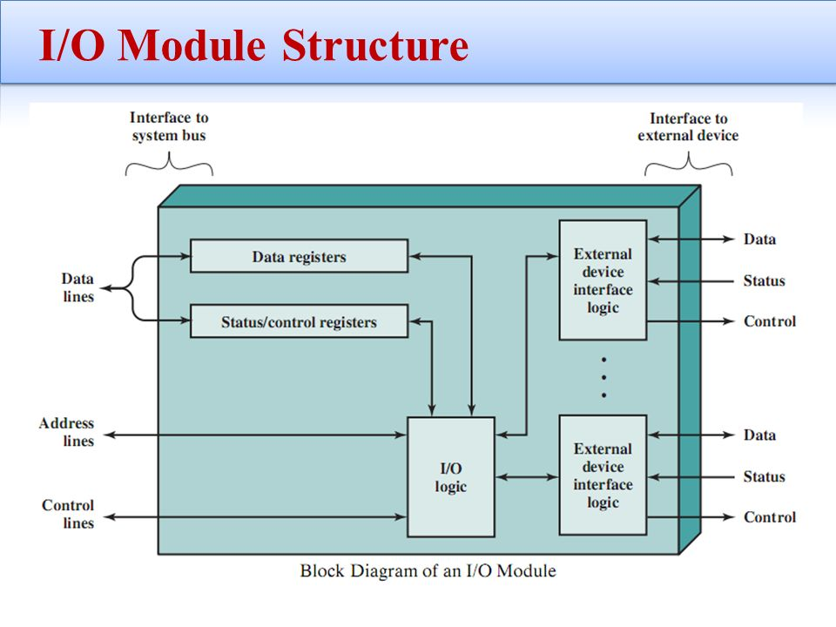

**(b).Discuss the Direct Memory Access operation in regard to data transfer in an I/O module.**

DMA stands for *"Direct Memory Access"* and is a method of transferring data from the Computer's RAM to another part of the computer without processing it using the [CPU](http://ecomputernotes.com/fundamental/introduction-to-computer/what-is-cpu). While most data that is input or output from your computer is processed by the CPU, some data does not require processing, or can be processed by another device.

In these situations, DMA can save processing time and is a more efficient way to move data from the computer's to other devices. In order for devices to use direct memory access, they must be assigned to a DMA channel. Each type of port on a computer has a set of DMA channels that can be assigned to each connected device. For example, a PCI controller and a hard drive controller each have their own set of DMA channels.

For example, a sound card may need to access data stored in the computer's RAM, but since it can process the data itself, it may use DMA to bypass the CPU. Video cards that support DMA can also access the system memory and process graphics without needing the CPU. Ultra DMA hard drives use DMA to transfer data faster than previous hard drives that required the data to first be run through the CPU.

An alternative to DMA is the Programmed Input/output (PIO) interface in which all data transmitted between devices goes through the processor.